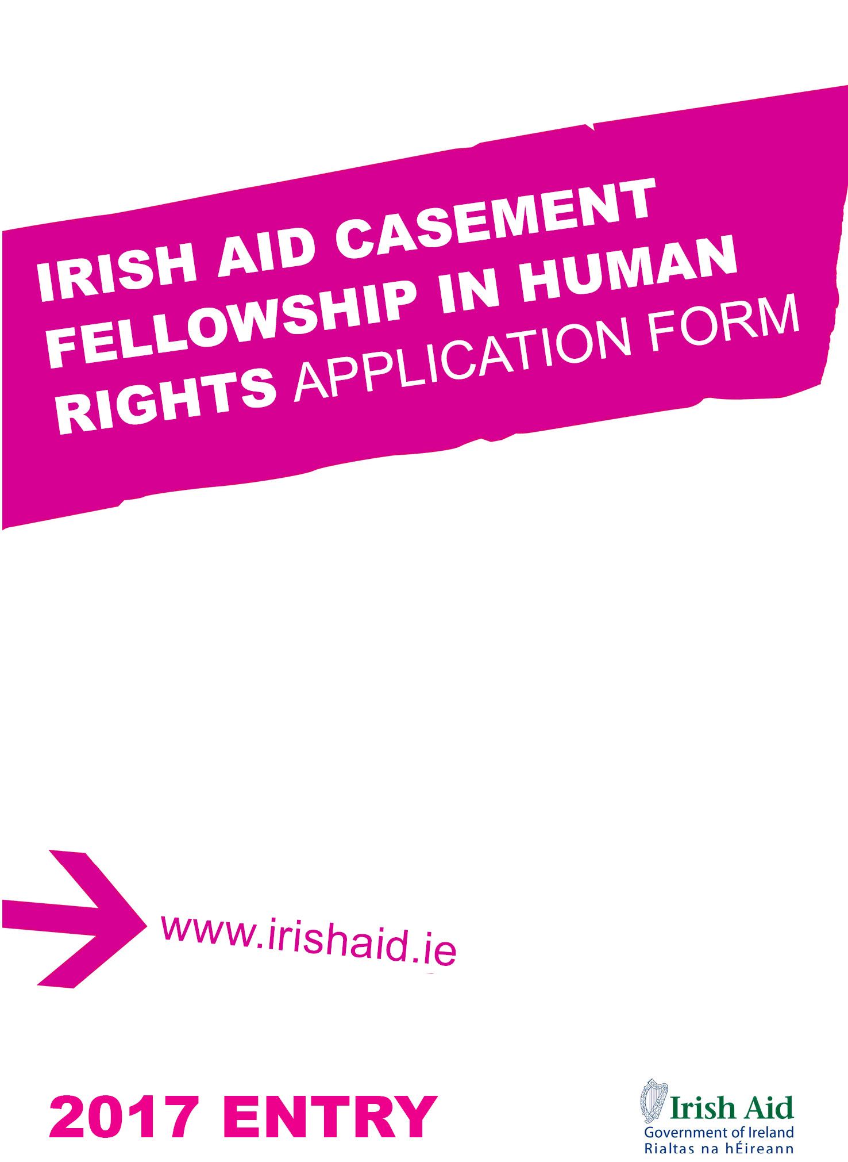

Irish Aid Casement Fellowship in Human Rights
Information Sheet

Please read the information below carefully before completing the application form

The Roger Casement fellowship has been established to honour the memory of the Irish human rights activist Roger Casement who spent some of his early working life in Calabar, Nigeria. He was an early advocate for human rights while in Nigeria, and, famously, during his later work in the Congo, the Amazon and in Ireland. With his humanitarian legacy in mind, it has been decided to support one Nigerian student to study a master’s degree in human rights in Ireland.

Under the Casement fellowship, full financial support is provided for one-year full-time post-graduate education for candidates from Nigeria to undertake a one year master’s level course of study in Human Rights in Ireland. The purpose of the Irish Aid Casement Fellowship Programme is to provide talented candidates with the opportunity to pursue advanced education and professional development in Ireland in order to contribute to the future development of Nigeria. The Irish Aid Casement Fellowship Programme normally covers: return airfares, full tuition, stipends to cover accommodation and subsistence costs, health insurance and other allowances, in addition to the necessary entry arrangements such as medical examination and visa.

For this fellowship, the eligible courses are listed under category H ‘Law, Human Rights, Governance and related’ in the Irish Aid Fellowship Training Programme Directory of Postgraduate Courses suitable for Fellowship Awards 2017 (for 2017-2018 Entry).

To Apply
In order to be eligible for this programme, candidates MUST:
- be a citizen of Nigeria and be residing in Nigeria
- have achieved the necessary academic standard to be accepted onto a master’s level course of study in Human Rights
- have a minimum of three years relevant work experience.
- be able to demonstrate a strong commitment to the development of Nigeria.
- be able to take up the fellowship in the academic year for which it is offered.
- meet any relevant procedural requirements of Government of Nigeria.

In addition, all candidates for study at an Irish Higher Education Institute must demonstrate their skills in academic English via a recognised test (IELTS) and must either:

- provide an original copy of a previous test result - IELTS (minimum 6.5) taken within two years of the application date or
- submit proof of a minimum IELTS score of 6.5 at the time of application (see www.ielts.org for IELTS details)

Irish Aid particularly welcomes candidates from candidates living with disability or candidates from disadvantaged groups in Nigeria.

To apply, please fill in the attached application form, paying special attention to the following criterias:
- Your commitment to returning to work in Nigeria following graduation.
- Your proposed future contribution to the social and economic development of Nigeria

If offered an Irish Aid fellowship, candidates will be required to:

- undergo a medical examination prior to confirmation of the fellowship award.
- be able to satisfy immigration requirements for international student entry to Ireland, if applicable.

A completed application package should include the following documents listed by order:
- Copy of your passport (details page) and Nigeria identity card.
- A certified copy of academic transcript and degree.
- One letter of reference from your employer.
- A completed application form, available at www.irishaidfellowships.ie should be submitted to the following address by 17 March, 2017:
Irish Aid Casement Fellowship Coordinator
Embassy of Ireland
11 Negro Crescent
Maitama District
Abuja
Nigeria

Failure to provide any of the above documents will render your application incomplete. Only short-listed applicants will be contacted for an interview. Final interviews will be held in Abuja in April 2017. Scholarship award winners will be announced by June 2017.

For further information, kindly contact Mr Eoghan McSwiney at: casementfellowshipnigeria@dfa.ie

2017 – 2018 Irish Aid Casement Fellowship in Human Rights  Application Form  Closing Date: 17 March 2015 | Please  attach  passport-size photograph  here

- Please read the information on the preceding page carefully before completing this application form
- Please TYPE to complete the application form

Section A: Personal Information

1. Please write your name in bold capitals and as written in your passport –if you are holding a valid passport, please attach a copy of the photo page.

- Full Name: ……….………………….…………………………........................................
- What name do you like to be known by? (i.e. your first name or given name).................

2. Contact Details
a) E-mail address: ……………………….……………….....................................................
b) Mailing address (where registered post can be delivered and signed for) : .…………….....
……….……………………………………………………………...…………………………..
d) Home phone: ………..………………. e) Cellphone: .………………..………….….......
3. Date of Birth :………………………………. 4. Place of Birth : ……………………..
5. Gender Male Female
6. Ethnicity
7. Family Details
Marital status: Single Married
Number of children (if any): ……………... Number of other dependents (if any): ……….....

- Have you convicted of a criminal offence? Yes No
If the answer is Yes, please provide details of the offence for which you were convicted, including the nature of the offence and the sentence received.

9. Emergency Contact
a) Full Name: ..……….…………………………………………………………………

b) Address: .………………………………………………………………………...…
c)Telephone: ……..……...…… d) Facsimile: ……………………………
e) E-mail address: ………………… f) Relationship to you: …………………
Section B : Education and Qualifications

 | High School | Third Level Education | Post-graduate Education
Name and Address of School
Date of Entry
Date of Completion
Certificate/Degree obtained
Honours and Awards (if any)

10. Overseas training
If you have attended any relevant educational or vocational training courses abroad, please provide names, locations, times of commencement and completion, and certifications awarded
(Please attach certificates)

11. Other Honours and Awards
State if you previously held a fellowship or other awards for studies abroad from the European Union, United Nations, other governments or development agencies. (Please attach certificates)

12. Have you ever applied for an Irish Aid funded study programme? Yes No

If yes, please indicate your application(s) result Successful Unsuccessful

Year(s) of application(s): …………………...

13. Have you applied, or are you intending to apply, for another scholarship at the same time as this application?

Yes No

If you answered Yes, provide the full name of the sponsor and the scholarship.

Sponsor:

Scholarship:

14. Required Standard Tests

14.1 IELTS
a) Have you sat an examination in academic English? Yes No
Proceed if the answer is yes.

b) When and where? …………………………………………………………………………

c) What is your overall score? .……………………………………………….……………
(please attach original transcript of results)

Section C: Statement of intent

15. Please set out how you intend to contribute to the development of Nigeria? Why do you want to pursue nominated course? How will you use the knowledge and skills acquired through your proposed course when return to work? (no more than 500 words)

16. Please describe your two most significant achievements in both your professional and social activities to date. (no more than 300 words for both examples)
Candidates should be specific about the context, task or project e.g. why it was important, how they went about it, what their specific role or contribution was and the impact or outcome.

Example 1

Example 2

Section E: Employment and Professional Information

17. Employment History
For each position you have held whether as an employee, student or volunteer (Attach an extra page if necessary)

Employment History
Name and Address of Organization
Type of organisation
Name of your Supervisor
Contact details:
Telephone
Facsimile
E-mail
Date of your entry
Date of your leaving
Position(s) and Responsibilities (if you have more than one position to state, start with the most recent one)
Most significant achievement
What you learnt in this job
Reasons for leaving

Section F: Declaration

I am in good health and, if accepted for an Irish Aid Casement Fellowship in Human Rights, will undertake the necessary medical examinations and provide the required medical certificates.

I understand the purposes for which the Irish Aid Casement Fellowship in Human Rights is awarded and the necessity to abide by the conditions specified.

I accept the requirement to return to my country to work on completion of my studies.

I certify that all the information I have given is true, complete and accurate to the best of my knowledge.

Signature: …………………………………….… Date: ……………………………

