APPLICATION FORM

SEED FUNDING FOR AFRICA-EUROPE YOUTH CO-OPERATION 2015

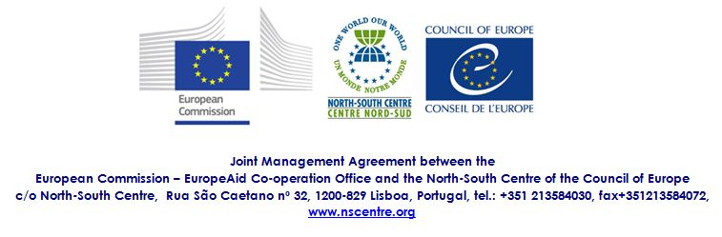

Please type or write legibly. If necessary, please attach an extra sheet(s) to the application form.

- INFORMATION ABOUT THE ORGANISATION

- Applying organisation
Name:
Postal address:
Contact person for the project (not necessarily the legal representative):
Telephone: Fax:
E-mail: Internet address:

- How would you best describe your organisation? (multiple answers possible)

an international youth organisation a national youth council (name):
a national youth organisation a local/regional youth organisation
a development NGO a governmental institution
a minority or minority rights association a network of organisations/associations
other (please specify):

- What is your organisation’s interest, background and future plans in youth co-operation within the Africa-Europe context? (max. 250 words)

- Bank details and legal representative (information to be used for Administrative Arrangement, if project granted)

Account holder:
Name of Bank:
Branch area:
Branch:
Bank Address:
Full bank account number:
IBAN:
Swift Code (BIC):

Name of legal representative (to sign administrative arrangement):

II. INFORMATION ABOUT THE PROJECT
- Name of the Project

- Brief summary description of the project. (max. 350 words)

- What is the Africa-Europe dimension of your project? Please describe. (max. 200 words)

- Please outline briefly the following elements of the project:

- overall aim

- specific objectives

- expected outcomes

- duration of the project

- target group(s)

- participation of the target group(s)

- in the design and implementation of the project

- evaluation mechanisms (internal and/or external)

- budget allocation (max. 2500€)

Expenses | Amount
International travel
Local transport
Board and lodging
Visa expenses
Fees for experts
 | TOTAL | €

Please describe in a detailed way in which way the grant will be used (e.g. flight ticket of a participant, trainers’ fees).
Please use Euro (€).

- What is the personal motivation of the participant(s) to take part in the project/ exchange/event? (max. 150 words)

Name of legal representative: ……………………………………………………

Signature and stamp: ……………………………………… Date and place: …………………………………

The application should be sent to
nsc.africaeurope-youthsummit@coe.int
or fax nº: +351 213 584 072
Deadline for submitting the application is 22nd February 2015

