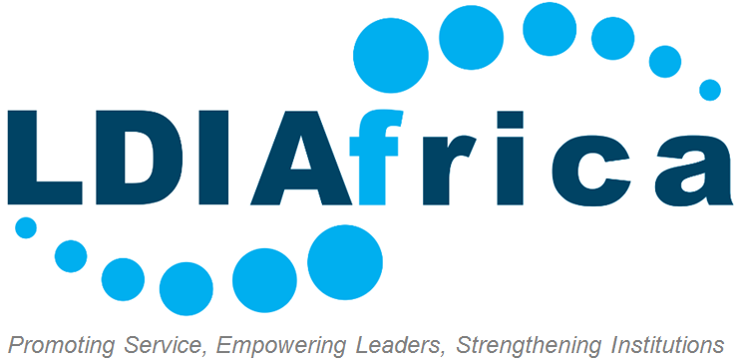

emerging institutions Fellowship program Application

Please complete the following essay questions to the best of your ability. Limit your answers to 300 words for each response.

To submit:
1. Rename this document using your personal information: “First Name, Last Name, Essays”
2. Save as a Word document
3. Email with your with your cover letter, resume and recommendation letters to apply@ldiafrica.org

Personal Biography (one paragraph in third person):

Please write a one-paragraph biography about yourself focused on your professional background. This biography serves as the first impression to our Host organizations and should focus on your professional accomplishments and acquired skills. See the biographies of current Fellows on our site for examples.

Essay Questions (Answer all):

- Why do you want to be an LDI Africa Fellow, and why have you chosen to serve in Africa at this time in your professional career?

- What do you see yourself doing professionally in the next five to ten years?

- What are your expectations from the fellowship and what do you plan on doing with the fellowship after it has been completed? Please be specific.

- Please describe any professional experience while living or working in an emerging market country, particularly in Africa.

- Please indicate any professional milestones, awards or accomplishments you think we should be aware of.

REFERENCE FORM

REFERENCE 1

FULL NAME:

JOB TITLE:

COMPANY:

PHONE:

EMAIL:

RELATIONSHIP TO YOU:

REFERENCE 2

FULL NAME:

JOB TITLE:

COMPANY:

PHONE:

EMAIL:

RELATIONSHIP TO YOU:

We advise that you have your recommendation letters ready as soon as possible to avoid any delays when we will ask you to submit them after the preliminary interviews; in the case that you are shortlisted.

